Debris Flow Risk Assessment in District Chitral, Eastern Hindu Kush, Pakistan
Shakeel Mahmood and Attia Atiq
Department of Geography, GC University Lahore, Pakistan
Corresponding Author: Shakeel Mahmood
shakeelmahmoodkhan@gmail.com
Abstract
The aim of this study is debris flow risk zonation using geological and hydrometeorological indicators in district Chitral, Hindukush Region Northwest Pakistan. The research is based on secondary data. Multi criteria Analysis (MCA) in Geographical Information System (GIS) environment was used to achieve the objective of the study. The geological and hydrometeorological parameters were analyzed by making five classes of each parameter. The classes are ranked as most favorable and least favorable with numerical weights. The weights were assigned in accordance to their importance in debris flow occurrence. Then weighted overlay analysis techniques were applied to develop composite map representing the importance of each factor. Debris flow risk zonation map was resulted into four classes very high risk zones, high risk zone, moderate zone, low risk zone. The geology of the study area is diverse with frequents earthquakes. Similarly the forest cover is decreasing due to anthropogenic activities. The area is also characterized by long cold winters with frost action. These factors are destabilizing the slope. During summer season rain storm event results high surface runoff and peak discharge in the perennial and non-perennial channels which results flood and debris flow. These events result human life loss and disruption. The main villages located in very high risk zone are Mulkoh, Mastuj, Reshun, Shegram, Terich Gol, Rogar, Asurat, Boni, Brep and Rech Tockhow. They have been frequently affected by hazard in the past decade. Out of the total area, very high risk zone is expanded over 8%, high risk zone is expanded over16%, moderate risk zone is 29% and the rest is low risk zone. This study has highlighted the risk zones which will help disaster management authorities and policy makers to reduce the risk of debris flow in future.
Keywords: Debris flow; Hazard; MCA; GIS; Slope; Lithology; Chitral.
- INTRODUCTION
Pakistan is prone physical and hydro-meteorological disasters ^{[1-2]}. Debris flow is one of the natural disaster resulting human losses and damages to properties and infrastructure ^{[3]}. The magnitude and frequency of debris flow events has increased due to increase in torrential rainfall events. In the year 2016, disastrous events were occurred with devastating effects. The nature and effect of this event was variable because of spatial variation in topography, surface lithology, land cover and population density ^{[4]}. Heavy rainfall remains the major causative factor of debris flow. Debris flow is geomorphic event which is greatly concerned with slope and stream channels ^{[5]}.
Debris flow risk reduction has been a major subject of discussion amongst the researchers worldwide. Multiple models were used in the past and still the contemporary researches follow multiple experimental studies in order to reduce risk and for calculating debris flow intensities and magnitude ^{[6]}. Risk is defined as the negative impacts that share large number of losses resulting from natural to human induced hazards; Risk reduction analysis is a modern technique to evaluate impact of hazard to the environment. It relies on the occurrence of event, element exposed to risk, level of damage, population exposed to the area at risk and importantly cost of goods in the area at risk ^{[7]}. The effect of risk could likewise be arranged into three noteworthy sorts that are primary impacts, secondary impacts and tertiary impacts ^{[8]}. The overall trend of natural hazard has dramatically increased worldwide in the recent decade. The particular causes include urbanization and climatic changes; the prominent evidences of natural hazard increment could be clearly witnessed in the metropolises that are marked at highest risk of natural hazards ^{[9]}.
Debris flow is a trend of hilly areas in most of the situation; it occurs abruptly with the flow that has high velocity and could give life threatening impacts. Debris flow on other hand is also referred as the most poorly predictable natural hazards having adverse impacts ^{[10]}. Debris flow for the most part starts on hilly areas or steep gullies and apparently observed to be more in serious climate conditions. It is also defined as mud flow ^{[11]}. Debris flow is the most dominant mechanism in which huge mass of debris is moved down the slope in the shortest period of time having high velocity. It happens with the combination of water, sediments and slope gradient. There are two types of debris flow confine and unconfined debris flow. Confine debris could happen in indented channels that could later progress toward becoming avalanche slides channel. Unconfined debris flow happens in already non scored channels with rare vegetal cover ^{[12]}. There are two types of factors that trigger debris flow. The first one is preliminary factors that include slope failure, extreme climate, weak rocks and low vegetation. The activating factors include intense rainfall; earthquake and high ground water level ^{[13]}.
Pakistan is hit by several disasters that result in the human, economical, social and environmental loss. The years 2005, 2007, 2009, 2010, 2011, 2012, 2014, 2017 and even 2022 were the most unfortunate years in its history. Khyber Pakhtunkhwa is hit by number of hazards including flash floods, avalanche, earthquake and internal displacement. District Chitral is highly prone to flash floods, debris flow, avalanches and earthquakes located in the eastern Hindu Kush Region ^{[1]}. Since 2007, the frequency of avalanches has been increased [14]. Recent studies in Chitral demonstrate that it is broadly inclined to two risks factors that are more dynamic than other which incorporate floods and debris flow ^{[15]}. The increasing frequency of avalanches and floods are additionally connected with the climatic changes ^{[16]}. This paper presents the assessment of debris flow hazard in district Chitral Eastern Hindu Kush, Northwest of Pakistan. Analyses of geological, hydro-meteorological and topographic aspects were carried out to highlight debris flow generating factors.
- LITERATURE REVIEW
Globally, the human its society and civilization are open to hazardous events that are as old as the earth [17]. Debris flow is also one of those which is a major threat to “human life”, “property”, “constructed facilities”, “infrastructure” and “hilly regions” ^{[17]}. It is accountable for rigorous damage and losses worldwide. According to one of the survey conducted globally proved that there are “213 debris flow” events between “1950 to 2011” that caused the “77779” fatalities. According to “Center on Epidemiology of Disaster” landslide alone is accountable for 17% of the lives losses globally. The median of 165 people are suffered in debris flow. North America has lowest median whereas South America and Asia has highest median which also prove that developing countries are more prone to debris flows; the countries are also characterize by high poverty, weak and corrupt government ^{[18]}.
In Mameyes 560mm of rainfall in 24 hours time frame activated debris flow bringing about 129 fatalities. In Venezuela 0.174 m of precipitation within five hours set off various shallow avalanches and debris flow bringing about 210 fatalities. In Rio de Janeiro and Petropolis, Brazil serious precipitation activated “landslide” that brought about 320 fatalities. In Antofagasta, Chile precipitation rates as extraordinary as 60 mm/hr amid a three-hour time frame activated “landslides” that brought about 101 fatalities. In Vargas, Venezuela overwhelming precipitation surpassing 0.9 m over a three-day term, with day by day values more prominent than the 1,000 year return period, activated a huge number of “landslides” and brought about an expected 30,000 fatalities. In Guinsaugon, Philippines overwhelming precipitation activated enormous “landslides”, covering a primary school that had 246 understudies and 7 instructors ^{[29]}. The noteworthy landsides happened in the time of 1990-2003. In 1990 avalanche happened in Nilgris in which 30 individuals died and a few harmed the “landslide” made substantial misfortune correspondence systems. In 1991-1992 two “landslide” happened in Assam and again in Nilgris in which 300 individuals died and serious harm to streets and structures in the joined loss of Nilgris and Assam the assessed misfortune is of 5 million ^{[20]}.
One of the studies correlated historical data of two debris flows in two closest unburned basins in “San Bernardino mountains of Southern California” and concluded that “larger basins” results to produce more water enriched and high velocity debris flows ^{[21]}. A study calculated 3290 debris flows event in Sichuan province of “Southwestern China” in which “spatio-temporal” distribution of debris flow and their activities were recognized. With the help of meteorological data and topographical data the province was classified into “slight”, “modern” and “very severe” regions in context to debris flow ^{[23]}. Pakistan has geographical and topographical set up located at the plate boundaries due to which it is highly vulnerable to natural hazards like earthquake, floods, landslides and water logging. During the past three decade major causes of natural hazards have been witnessed which particularly include “geological factors”, “climate change” and “urbanization”. In Pakistan nearly percentage of 75 of household has been affected by landslides ^{[23]}.
Multi Criteria Analysis (MCA) is a latest method practiced by numerous researchers to learn a hazard with multi criteria approach. The main reason of MCA is to create “vulnerability map” for decreasing the risk. MCA studies majorly focused the “causative factors”. The natural causative factors include “precipitation”, “geology”, “slope”, “aspect”, “and earthquake”, “land use and land cover”. Slope is an important factor it determines the speed of debris flow. Land use and land cover are also important factors for the debris flow risk assessment. More vegetated and land cover area would have less chances for the maximum damage. Land use and land cover are also classifies into five classes named as forest, agricultural area, barren area, built up area and water area. Precipitation also play a vital role in the debris flow it is also termed as triggering factor of debris flow ^{[24]}.
Debris flow hazard are most difficult to be forecasted but numerous techniques provided a platform to predict debris flow as well as an efficient early warning system. The studies majorly include “regression analysis”, “GIS techniques”, “artificial neural network”, “mathematical calculation” and “similarity based hazard assessment” for determining hazard level of debris flow and predicting and analyzing debris flow events ^{[26]}. Debris flow risk assessment majorly includes “frequency magnitude analysis”, “consequence analysis” and “numeric scenario modeling” for calculating the severity of the debris flow events. Quantitative Risk Assessment (QRA) is a recent technique for assessing landslide risk for public safety first used in Honk Kong. GIS techniques are also friendly techniques for risk assessment. The debris flow hazard assessment is a framework adopted by the researchers and engineers to design risk reduction measures” ^{[26]}.
- STUDY AREA
Chitral is the region located at 35.8523º N, 71.7871º E in the “Hindu Kush Mountain” range of Pakistan at the elevation of “3,700 ft” having area of “14850” square kilometers (Fig. 1). Chitral is the largest district of Khyber Pakhtunkhwa it is exactly present at the base of Tirich Mir the fifth largest peak of the world. Chitral is hot in summer that varied having maximum temperature and hotter weather patterns in low lands whereas remains cool in higher elevations. Spring weather may bring mild rainfall and even snow in few areas. Autumn remain pleasant throughout the region. The extreme weather in summer was recorded in Chitral in the month of July that was 36ºC. The livelihood of Chitral depends on agriculture and natural resources. Chitral was given district status in 1953 ^{[27]}.

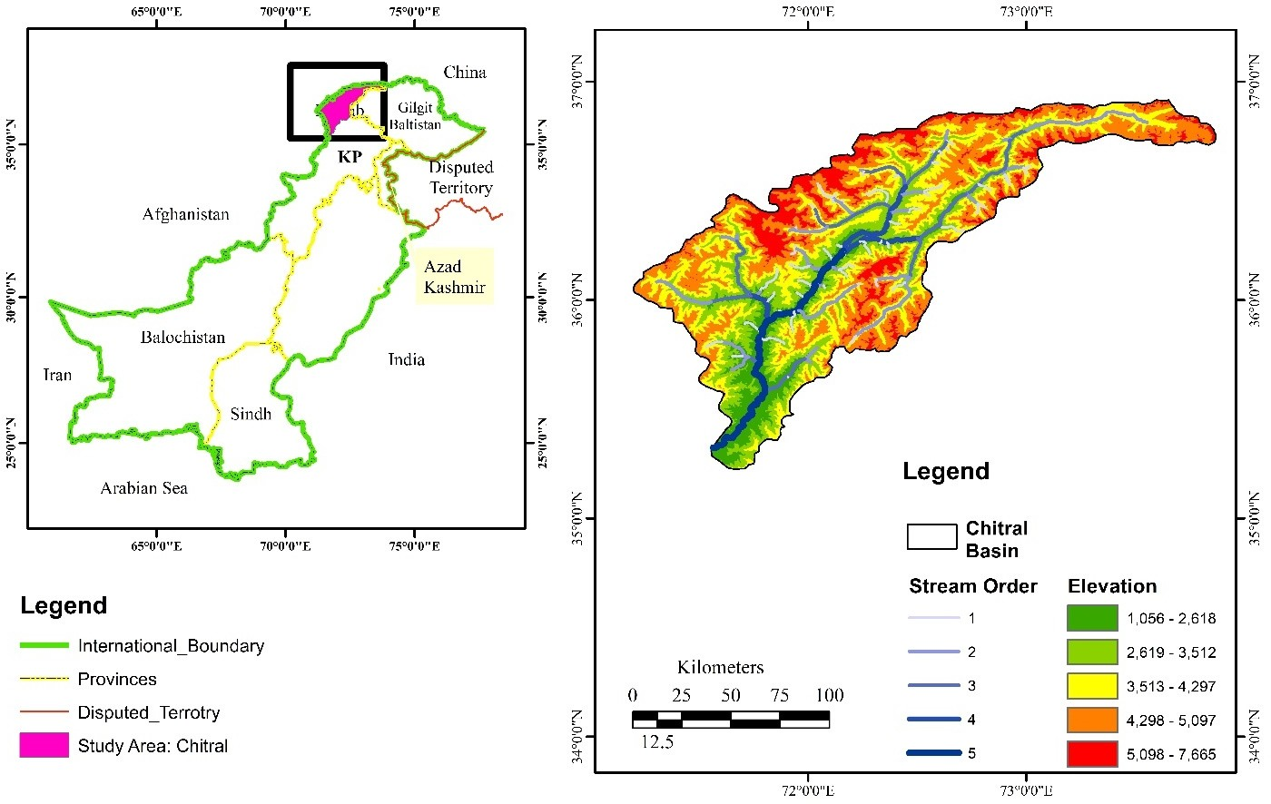
District Chitral
Pakistan Location of District Chitral

Fig. 1 Location of Study area

The Chitral Mastuj Valley is possessed by three of most noteworthy mountain network of the earth. The Hindu Kush extend in the west, Hindu Raj go in the east and in the middle of is the Shandhur Karakorum run. The region has various tops more than 20,000 ft. Chitral because of its severe weather conditions, topography, geographical location and certain other manmade factor remained exposed to disasters including flash floods, soil erosion, avalanches, landslides, earthquakes and droughts. The major cause of disasters also include climate change which is responsible to trigger two disasters majorly avalanches and flash flooding. According to International Panel for Climate Change (IPCC) fifth assessment report global surface temperature has increased whose impacts could be clearly witnessed in Chitral as well. The review demonstrated that there is an expansion in most extreme yearly temperature and decline in least temperature. The occasions of avalanches slide and floods are likewise connected with the climatic changes. The events of avalanches and landslides lies on second and third rank respectively in the areas of Doaba, Mardan, Gobor, Hearth, Parsan, Shoghor and Susume. On March 2016, an avalanche hit the village of Susam in which 10 children were killed while returning from school. Only two bodies were recovered and rests of the 8 were not able to be recovered. According to District Commissioner of Chitral the main hurdle while recovering bodies was the non-availability of heavy machinery ^{[28]}.

- METHODOLOGICAL FRAMEWORK
The following methodology was adopted to achieve the objectives of this research. The selected variables for the research work includes precipitation, geology, slops, aspect, earthquake, land use and land cover. Meteorological data was collected from multiple sources for the complete authentication and reliability of data the departments were visited personally for the collection of data. The meteorological data of Chitral was collected from Regional Meteorological Center Peshawar. The most important data was collected from Provisional Disaster Management Authority (PDMA). The two days visit was made to collect the data because the data was highly sensitive. PDMA provided the historical data of disasters with complete database of disasters with locations of Chitral since 1900 to 2016. Earthquake data was collected from the District Government Chitral who provided the data from 1980 to 2015. The data covered the epicenter, focus, locations, depth, magnitude and dates of occurrence of the earthquakes. Village’s data was also provided by District Government Chitral. They provided a database which covered the events occurred in the villages, their names and the date of occurrence of the events in the specific village. The data was collected personally because of the security concerns. The data regarding bridges, culverts, roads were collected from Construction and Work Department, KP. Chitral boundary data was collected from PDMA, Peshawar. Digital Elevation Model (DEM) having 30 meters spatial resolution was downloaded from USGS online geo-database for watershed delineation.
4.1 Data Preparation
ArcGIS was used to digitize satellite image. Land use and land cover data was further classified into classes named as forest, built up areas, barren area, water area and agricultural land. The precipitation data was interpolated using ArcGIS. The watershed delineation was done using ArcGIS 9.3. The watershed delineation was done to calculate the slope and aspect for further analysis. The spatial data was prepared in order to generate vulnerability map using MCA and GIS tools. Watershed delineation was done by using DEM of Chitral using SRTM DEM having spatial resolution of 30m, downloaded from USGS online geo-database. The data collected from Regional Meteorological Center was tabulated in Excel sheets. After the data entry into Excel sheets the averages were calculated for each station from the year 2005 to 2015.

  - Data Analysis
The data analysis includes MCA Multi Criteria Analysis. MCA technique is a method to assess debris risk using GIS technique after Jakob et. al. ^{[29]} and, Mehmood et. al. ^{[30]}
4.3 Identification of causative factors
The natural causative factors include precipitation, geology, slops, aspect, earthquake, land use and land cover. The classes were made for each factor and the ranking was applied for each class from 1 to 5 where 1 representing the highest value and 5 representing the lowest value. ArcGIS 9.3 was used for transferring the data into GIS layer.
1) Precipitation: The spatial distribution of rainfall has been performed using spine interpolation method using GIS technique. The classes are made using weight overlay analysis.
2) Slope: Slope is an important factor it determines the speed of debris flow it is showed in percentage. The classes for slope are made by using DEM of the study area.
3) Land use and land cover: Land use and land cover are also important factors for the debris flow risk assessment. More vegetated and land cover area would have less chances for the maximum damage. Land use and land cover are also classifies into five classes named as forest, agricultural area, barren area, built up area and water area.
4.4 Evaluating debris flow vulnerability
In the second phase the method of MCA and GIS technique is applied to evaluate debris flow vulnerability of the area. GIS tools are used for managing, producing and analyzing spatial data. Using GIS tool debris flow vulnerable map is made in order to analyze the highest risk zone and lowest risk zones. The debris flow vulnerability map evaluates the area into acceptable, moderate, undesirable and unacceptable classes.
4.5 Weight overlay analysis
Weight overlay analysis is used for MCA. The data were categorized into different classes and then each class is ranked as most favorable and least favorable using Delphi Technique (Table 1).
Table 1: Debris Flow Causative Factors Weights
Factors | Factor Classes | Weight of each classes
Precipitation | 0-50 mm | 4
 | 50-100 mm | 5
 | 100-150 mm | 3
 | 150-200 mm | 2
 | 200 > | 1
Slope | 0-5 % | 1
 | 5-15 % | 2
 | 15-30 % | 3
 | 30-55 % | 4
 | 55-80 % | 5
Landuse | Forest | 1
 | Agriculture | 3
 | Barren land | 5
 | Range lands | 4
 | Meadows and bushes | 2
Events | Avalanche | 5
 | Snowfall | 4
 | Mudflow | 3
 | Landslides | 2
 | Rockfall | 1
Earthquake | < 2 Magnitude | 1
 | 2.1-3 | 2
 | 3.1-5 | 4
 | 5.1-6 | 5
 | > 6 | 3
River Network | 1st Order- 5th Order | 5
 | 1st Order- 4th Order | 4
 | 1st Order- 3rd Order | 3
 | 1st Order- 2nd Order | 2
 | 1st Order | 1
Frequency of Events | <2 | 1
 | 3 to 6 | 2
 | 7 to 10 | 3
 | 11 to 15 | 4
 | > 15 | 5
Source: Authors

- RESULTS AND DISCUSSION
The debris flow has a long history in the District Chitral according to the officials debris flow is most frequent occurring phenomenon in Chitral. The data gathered from Meteorological Department was from 2005-2015 the average temperature and rainfall trend are calculated as follow:
5.1 Rainfall
The rainfall trend is seen to be more in the months of January, February, March where as it is lowest in the months of June, July, August and October. In the year 2007, March received highest ever rainfall of 262.1 mm. Generally, January, February and March receive more rainfall. The analysis of ten years data revealed that the months of May, April and January have the decreasing trend in the rainfall patterns where as November has an increasing trend from 2005-2015. The month of December has an abrupt change in rainfall pattern than any other month, the abrupt change is seen in the years 2006, 2007, 2008 and 2009 where the rainfall is recorded to be increasing from 2 mm in the year of 2005 to 100 mm in the year 2006 and then the abrupt decrease in the year 2015 to 17 mm from 39 mm (Figure 2).

Figure 2: Average Rainfall of District Chitral (2000-2022) (Source: Pakistan Meteorological Department, 2022)

5.2 Temperature
The temperature is maximum in the month of July where as it is minimum in the month of January. The temperature is independent of rainfall in case of Chitral. The total average of maximum temperature showed that June is the hottest month in the last 10 years having temperature of 36.6º C where as January as the coldest month having temperature of 9.9º C. The temperature variation could be clearly seen in Figure 3 where the temperature record of 2005 and 2016 are compared. The detail clearly shows that there is abrupt increase in the temperature from 2005 and 2016. The increase temperature is the major reason for melting of glaciers hence it could be a reason to the occurrence of avalanche in the study area.
5.3 Debris flow events Study Area
Chitral is also seen to be an active area of Pakistan which is highly vulnerable to disastrous and life threatening hazards including flash floods, debris flow and avalanches. The studies conducted in Chitral shows that it is widely prone to two hazards that are more active than other which include floods and avalanche. The Figure 3 shows the total numbers of events in different villages; Khot has faced 6 events of debris flow from 1976-2021, SherShal has faced only one event of debris flow the most recent event of avalanche of 2017 in which there were 9 deaths, 4 injuries and 19 houses fully damaged. The data gathered from the village of Khot is the most targeted village and Sher Shal is the least targeted village; whereas Golen and Charun are the second most targeted villages (Table 2).
Geology of the area is comprised of both sedimentary and metamorphic structures that extend southwards from Chitral to Mastuj. The Reshun fault system is the most highlighted fault in Chitral Central complex. It comprise of sedimentary sequences that include grey slate to silt stone. Rocks at low metamorphic level include slate, marble, chlorite. Higher metamorphic level includes garnet-biotite staurolite and garnet- biotite schist.

Table 2: Debris Flow Events and Effected Villages
Sr. No. | Year | No. of events | Effected Villages
1 | 1956 | 4 | Breshgram,Ochu,Susum,Brep
2 | 1974 | 3 | Murdan,Madaklasht,Bresgram
3 | 1975 | 3 | Susum,Booni
4 | 1978 | 6 | Mastuj,Akari,Garamchashma,Mardan,Brep,Wajiue
5 | 1982 | 3 | Boroghul,Parwak,Reshun
6 | 1984 | 4 | Parwak,Khot,Domil,Shagram
7 | 1985 | 5 | Sorlaspur,Momi,Terich,Chapali,Gobore
8 | 1988 | 3 | Khot,ReckTorkhu,Gobore
9 | 1990 | 3 | Terich,Warijue,Bresgram
10 | 1992 | 3 | Yarkhoon,Melp,Herchin
11 | 1996 | 4 | Bang,Ochu,Susum,Lone
12 | 2000 | 4 | Ayun,Yarkhoon,Shagram,Bang
13 | 2004 | 5 | Madaklasht,Charun,Chapali,Golen,Khot
14 | 2005 | 15 | Sorlaspur, Momi, Mastuj, Golen, Khot, Melp, Mardan, Brep,Ochu,Lone,Morder,Bang,RechTorkhow,Bagusht,Parabeg
15 | 2006 | 4 | Ashtre,Booni,Brep,Borogul
16 | 2007 | 17 | Begusht,Mardan,SeenLasht,Brep,Bresgram,Morder,  Lone,Madaklasht, Terich, Momi,Akari,Charun,Khot,  Warijue,Shagram,Parabeg,RechTorkhow
Source (PDMA, 2021)

Figure 3 Villages with number of events of debris flow Source Provincial Disaster Management Authority (PDMA, 2016)

5.4 Hazard Zonation
The hazard of debris flow is frequent in the study area. But some areas are more prone to this hazard because of its location in hazard zone and causative factors. The areas bordering Gilgit could be clearly seen to be at the low hazard zone whereas the areas bordering the Afghanistan belt could be seen to be at low hazard zone to moderate risk zone. The central Chitral is the at the very high risk zone (Figure 4). In the central areas high hazard zone is delineated because of it frequency and spatial extent with damages. The main targeted villages at very high risk zone are Mulkoh, Mastuj, Reshun, Shegram, Terich Gol, Rogar, Asurat, Boni, and Brep Rech. The area at very high risk zone is 8%, high risk zone is 16%, moderate risk zone is 29% and the rest is low risk zone. The resultant map of debris flow risk zones is developed by applying Multi Criteria Analysis in GIS environment (Figure 5). This approach is globally recognized with good results and more accuracy.

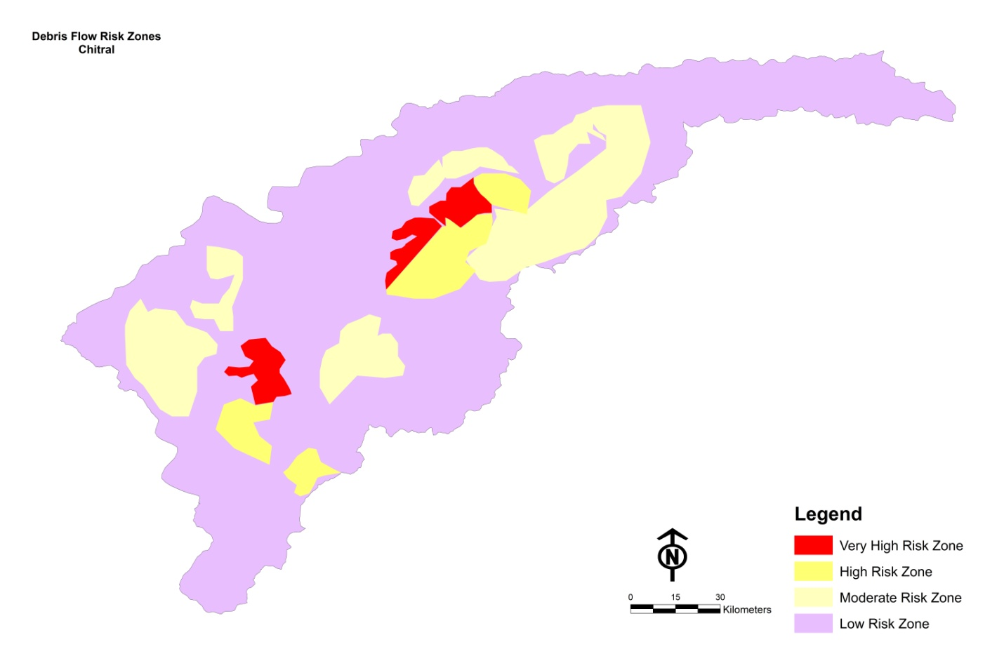

Figure 4: Debris Flow Hazard Zonation Source: Authors

DATA AQUISATION
DATA PROCESSING

Slope
Precipitation
LULC
DEM

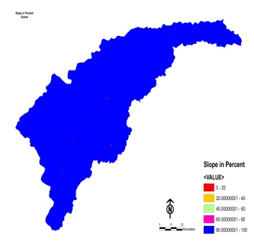
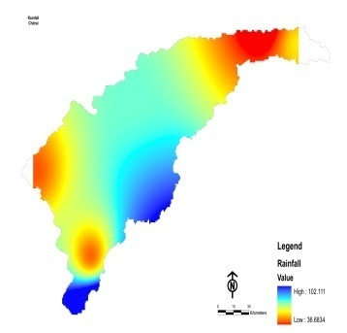
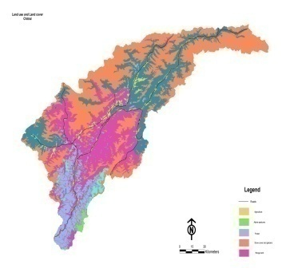
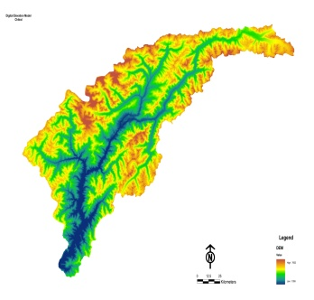

Weights and combination of datasets

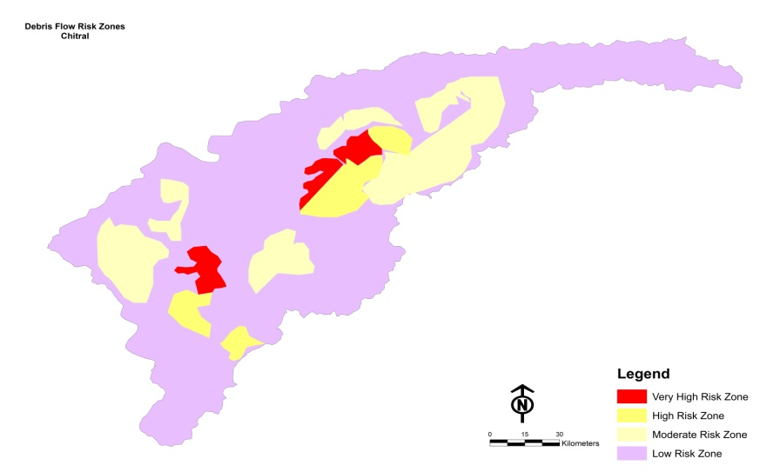

Figure 5: Framework of data processing using MCA in GIS tool Source: Authors

- CONCLUSION
Debris flow is the most common phenomenon in Chitral. Variation in geology, weathering process, steep slope and rainfall are the leading factors of debris flow. The study showed that there is abrupt increase in the temperature from 2005 and 2016. The increase temperature is the major reason for melting of glaciers hence it is a reason to the occurrence of avalanche in the study area. Chitral comprise of land use and land cover having agriculture land, alpine pastures, forests, snow cover and glaciers and range land. The total agricultural area is of 3%, forest is 4.7%, 1.2% is shrubs and bushes, 62% of range lands, 4.1% of rocks, 24% of glaciers, 0.46% river beds, 0,02% of lakes and 0.13% of main habitation. The total area that is cultivated is 22,552 hectares and the irrigation sources are river and streams. The total cultivated area is of 22,552 hectares, 23,946 hectares of cropped area, and 41,949 hectares of forest. The distribution of Debris flow could be clearly witnessed in the area with the proximity of river. The most of the debris flow distribution could be witnessed in the central zone of Chitral. The main targeted villages at very high risk zone are Mulkoh, Mastuj, Reshun, Shegram, Terich Gol, Rogar, Asurat, Boni, Brep and Rech Tockhow. The area at very high risk zone is 8%, high risk zone is 16%, moderate risk zone is 29% and the rest is low risk zone.

Author Contributions: All authors contributed equally in the research work and writing the manuscript.
Conflict of Interest: "The authors declare no conflict of interest."
Funding: No funding
Acknowledgment: We acknowledged the PDMA for proving the relevant data.

References
- Mahmood S, Khan AH, Mayo SM (2016a) Exploring underlying causes and assessing damages of 2010 flash flood in the upper zone of Panjkora River. Nat Hazards 83(2):1213–1227.
- Mahmood S, Khan AH, Ullah S (2016b) Assessment of 2010 flash flood causes and associated damages in Dir Valley, Khyber Pakhtunkhwa Pakistan. Int J Disaster Risk Reduct 16:215–223
- Gautam, P., Kubota, T., Sapkota, L. M., and Shinohara, Y. (2021). Landslide susceptibility mapping with GIS in high mountain area of Nepal: a comparison of four methods. Environ. Earth Sci. 80, 359
- Rahman, G., Rahman, A.-U., Ullah, S., Miandad, M., and Collins, A. E. (2019). Spatial analysis of landslide susceptibility using failure rate approach in the Hindu Kush region, Pakistan. J. Earth Syst. Sci. 128, 59.
- Archetti, R., & Lamberti, A. (2003). Assessment of risk due to debris flow events. Natural Hazards Review, 4(3), 115-125.
- Meten, M., PrakashBhandary, N., & Yatabe, R. (2015). Effect of landslide factor combinations on the prediction accuracy of landslide susceptibility maps in the Blue Nile Gorge of Central Ethiopia. Geoenvironmental Disasters, 2(1), 1-17.
- Dowling, C. A., & Santi, P. M. (2014). Debris flows and their toll on human life: a global analysis of debris-flow fatalities from 1950 to 2011. Natural hazards, 71(1), 203-227.
- Park, D., Lee, S., Nikhil, N. V., Kang, S., & Park, J. (2013). Debris flow hazard zonation by probabilistic analysis (Mt. Woomyeon, Seoul, Korea). International Journal of Innovative Research in Science, Engineering and Technology, 2(6), 2381-2390.
- Fuchs, S., Kaitna, R., Scheidl, C., & Hübl, J. (2008). The application of the risk concept to debris flow hazards. Geomechanik und Tunnelbau: Geomechanik und Tunnelbau, 1(2), 120-129.
- Uitto, J. I. (1998). The geography of disaster vulnerability in megacities: A theoretical framework. Applied geography, 18(1), 7-16.
- Liu, Jinfeng, Kana Nakatani, and Takahisa Mizu Yama. "Effect assessment of debris flow mitigation work based on numerical simulation by using Kanako 2D." Landslide, 2013.
- Sung, C. H., & Liaw, S. C. (2020). A GIS-based approach for assessing social vulnerability to flood and debris flow hazards. International journal of disaster risk reduction, 46, 101531.
- Takahashi, T. (2009). A review of Japanese debris flow research. International Journal of Erosion Control Engineering, 2(1), 1-14.
- PDMA (2016). Overview of disaster in Khyber Pakhtukhawa; Impact respose and managing risk . Provincial Disaster Managment Authority,Khyber Paktunkhwa, Pakistan.
- Blistanova, M., Zeleňáková, M., Blistan, P., & Ferencz, V. (2016). Assessment of flood vulnerability in Bodva river basin, Slovakia. Acta Montanistica Slovaca, 21(1).
- Butt, M. J., Umar, M., & Qamar, R. (2013). Landslide dam and subsequent dam-break flood estimation using HEC-RAS model in Northern Pakistan. Natural Hazards, 65(1), 241-254.
- Nettleton, I. M., Martin, S., Hencher, S., & Moore, R. (2005). Debris flow types and mechanisms. Scottish road network landslides study, 45-67.
- Coe, J., Cannon, S., & Santi, P. (2008). Debris flows initiated by runoff, erosion, and sediment entrainment in western North America. Geomorphology (Amsterdam), 96(3-4).
- Kogelnig, A., Hübl, J., Suriñach, E., Vilajosana, I., & McArdell, B. W. (2014). Infrasound produced by debris flow: propagation and frequency content evolution. Natural hazards, 70(3), 1713-1733.
- Lan, H. X., Li, L., Zhang, Y. S., Gao, X., & Liu, H. J. (2013). Risk assessment of debris flow in Yushu seismic area in China: a perspective for the reconstruction. Natural Hazards and Earth System Sciences, 13(11), 2957-2968.
- Liu, G., Dai, E., Ge, Q., Wu, W., & Xu, X. (2013). A similarity-based quantitative model for assessing regional debris-flow hazard. Natural hazards, 69(1), 295-310.
- Jakob, M., Holm, K., & McDougall, S. (2016). Debris-flow risk assessment. In Oxford Research Encyclopedia of Natural Hazard Science.
- Staley, D. M., Kean, J. W., Cannon, S. H., Schmidt, K. M., & Laber, J. L. (2013). Objective definition of rainfall intensity–duration thresholds for the initiation of post-fire debris flows in southern California. Landslides, 10(5), 547-562.
- Tang, C., Zhu, J., Ding, J., Cui, X. F., Chen, L., & Zhang, J. S. (2011). Catastrophic debris flows triggered by a 14 August 2010 rainfall at the epicenter of the Wenchuan earthquake. Landslides, 8(4), 485-497.
- Khan, M. A., Haneef, M., Khan, A. S., & Tahirkheli, T. (2013). Debris-flow hazards on tributary junction fans, Chitral, Hindu Kush Range, northern Pakistan. Journal of Asian Earth Sciences, 62, 720-733.
- Uddin, Z., Zaman, T., Anjum, M., Uddin, S., & Uddin, N. (2020). Debris flow mitigation in Chitral Region, Pakistan. In Селевые потоки: катастрофы, риск, прогноз, защита (pp. 282-289).
- Amin, G., Bano, D., Wali, S., & Shah, S. (2020). Comprehensive analysis of surface characteristics of debris flow fans in Gilgit-Baltistan and Chitral regions of Pakistan using remote sensing. In Селевые потоки: катастрофы, риск, прогноз, защита (pp. 122-133).
- Uddin, Z., Anjum, M., Uddin, S., & Uddin, N. (2020). Debris flow hazard of glacial lake in Chitral, Pakistan. In Селевые потоки: катастрофы, риск, прогноз, защита (pp. 272-281).
- Jakob, M., Stein, D., & Ulmi, M. (2012). Vulnerability of buildings to debris flow impact. Natural hazards, 60(2), 241-261.
- Mehmood, Q., Qing, W., Chen, J., Yan, J., Ammar, M., & Rahman, G. (2021). Susceptibility Assessment of Single Gully Debris Flow Based on AHP and Extension Method. Civil Engineering Journal, 7(06).

